

# Student Information

Merritt Jermaine W. 3845178

**Student’s Last Name** **Student’s First Name** **Student’s M.I.** **Student’s CPCC Student ID#**

7014 Steele View Court

**Student’s Street Address (include apt. no.)** **Student’s CPCC Email Address**

Waxhaw NC 28173 980-297-4098

**City** **State** **Zip Code** **Student’s Telephone # *(include area code)***

|  |
| --- |
| **Warning: If you purposely give false or misleading information, you may be subject to a fine of up to** |
| **$20,000 or imprisonment for up to five years or both according to the U.S. Department of Education.** |



**Please use “My Progress” plan to complete the educational plan on page 3 of this appeal.** To locate, log into “MyCollege”, under the navigation panel to the left select “Academics”, click “Student Planning”, and then click on “My Progress”.

Students who have been disqualified from receiving financial aid due to exceeding the 150% time frame may appeal that decision by completing and submitting this form.

The maximum time frame in which to complete a degree is 150% of the published length of the program. A student may request a “recalculation” of the maximum time frame component in the following scenarios:

**1) a change in the program of study**; **2) attempting multiple programs**; or

**3) has successfully completed a program and is returning to pursue another program**.

If deemed appropriate, the recalculation would include only the credit hours that are applicable to a student’s current program of study. In case of multiple degrees, each program would be calculated separately to only include the credit hours that are applicable to each program.

**A student may only request the recalculation twice in their academic careers at Central Piedmont.** A review of the student’s remaining eligibility and the ability to complete will be taken into consideration for students completing multiple programs. The student must be meeting the GPA and completion rate requirements for a recalculation to be approved.

# Current Academic Program Information

**Degree Objective:**  **Associate Degree** **Certificate** **Diploma**

|  |  |  |  |  |  |  |  |
| --- | --- | --- | --- | --- | --- | --- | --- |
| **Name of Program** | Associate of Arts |  | | | | | |
| **Number of classes remaining complete** | | **degree** | | 5 | **Expected graduation date** | 12/16/2025 | |
| **Total credit hours required for degree** | | 86 | | | | | |
| **Total credit hours earned towarddegree** | | **e** | 68 | **Total credit hours remaining to earn degree** | | | 18 |



**Request for Recalculation Reason:**

**Change of Major**



◻

**New Program:**

**Reason**

**for**

**Change:**



◻

**Double**

**Major**

## **Programs:** ________________________________________________________________________

________________________________________________________________________

**Already completed a program**



◻

**Completed Program:**  **New Program:**

**Explanation on why a new program of study is necessary:**



# Educational Plan – Timetable for Remaining Coursework for Program Completion

All students submitting a Maximum Time Frame Recalculation Request must also complete and submit the information below, indicating all remaining required courses in your academic program. Any extension of financial aid eligibility will be limited to only those courses required to complete your academic plan/degree.

**Please record the classes you intend to take (Educational Plan) for the next four semesters or until your expected graduation date. If you graduate within four semesters. Use your “My Progress” (located in “MyCollege”) to assist you in completing this section.**

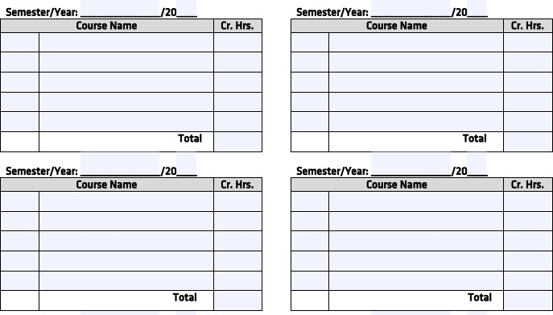

# 2024-2025 Maximum Time Frame Appeal

Describe the steps you plan to take to ensure your ability to follow the timetable of remaining coursework for program completion. Attach additional pages if needed.

To be considered for federal financial aid, you must provide a detailed explanation as to why you have earned more credits that your degree/certificate program requires, why you have changed your program of study, or if you already have a degree, why you are taking additional coursework.

# 2024-2025 Maximum Time Frame Appeal

This completed form, statement and supporting documentation should be submitted as soon as possible after Satisfactory Academic Progress emails are received. Classes will not be held if appeals are submitted or approved on or after the payment deadline. If you did not pay for your classes out of pocket and a payment deadline passes, your classes may drop for non-payment. You will be responsible for re-registering for available classes.

You will also be responsible for any bills incurred for courses that do not drop automatically for non-payment if your appeal is denied even if you choose not to attend classes.

**Incomplete appeals will not be reviewed.**

## **Statement of Understanding**

**By initialing each item below, you are indicating that you understand and agree to abide by the following conditions of the appeal if approved:**

I must achieve a semester Grade Point Average of 2.0 for each semester of approval.

I must maintain a 100% completion rate for each semester of approval.

I understand that I will only receive financial aid for the number of courses and/or semesters approved. If my appeal is approved, I will meet with an Advisor to develop an academic plan.

If I receive financial aid funds for classes other than those listed and approved on this form, my award

may be reduced or cancelled, and/or I may be suspended from any additional financial aid. Only the courses listed on my academic plan may be used to maintain and/or reinstate my financial aid eligibility.

A physical signature is required on this document. Digital signatures will not be accepted and may result in the request being denied. By signing this form, you are certifying that all information and supporting documentation provided is factual and complete. This also acknowledges that you understand and accept the above terms regarding both approved and denied financial aid appeals.

|  |  |
| --- | --- |
| **Student signature:** | **Date:** |

***Financial Aid – Central Piedmont Community College – PO Box 35009 – Charlotte, NC 28235-5009***